

Storm Debris Clean Up Report
July 27, 2012

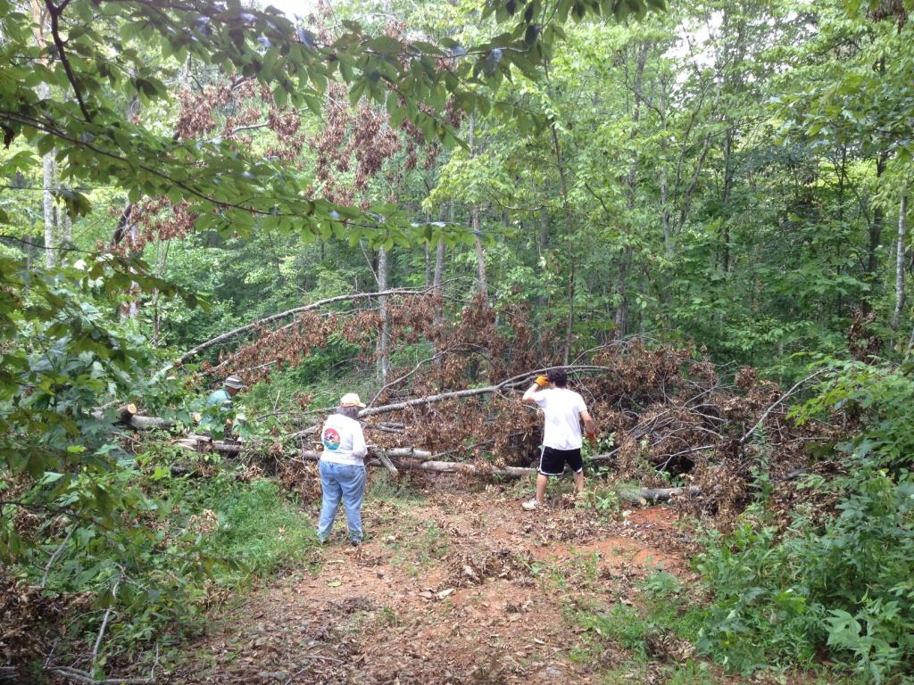

On June 29,2012, Virginia was hit by one of the most damaging storms in its recent history. The storm was a derecho, a type of severe summer thunderstorm accompanied by high speed winds and frequent lightning. These storms do not usually occur in Virginia, and there are usually only several in the country each year. The strong winds knocked down many trees, causing power outages over much of the state. Several more severe storms over the next few weeks added to the damages. At Stagebridge, homeowners reported that there was some storm debris blocking places on both White Tail Branch Road and Laurel Ridge Road, which are used to access several lots.

In total there were around fifteen trees that had fallen and were blocking these roads at various points. It took two days, approximately 8 hours, to clear all of the debris. Chainsaws and some hand tools were used to remove everything blocking the paths. We are happy to report that all the lots are once again accessible! The grass on most of the paths was also trimmed to better accommodate both cars and people.


